Jargon Buster



In this project you will train the computer to listen out for specific words.

You’ll use that to create a project in Scratch that will listen out for when those words are spoken. It will display what they mean any time it hears them.

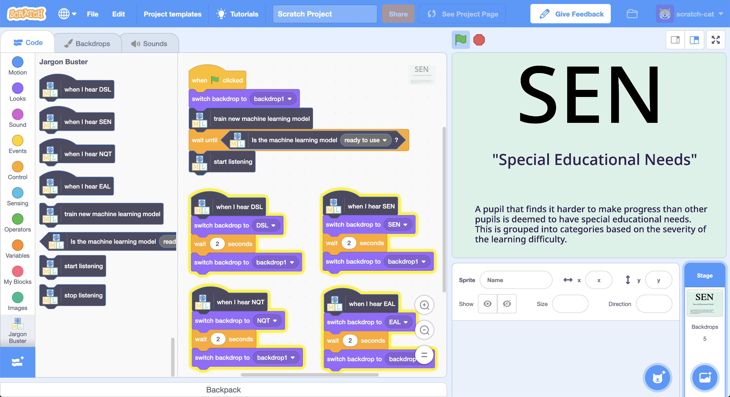

This project worksheet is licensed under a Creative Commons Attribution Non-Commercial Share-Alike License

http://creativecommons.org/licenses/by-nc-sa/4.0/

This project requires a **microphone**. If you don’t have a computer with a microphone, you might prefer to try a different worksheet.

1. Go to <https://machinelearningforkids.co.uk/>
2. Click on “**Log In**” and type in your username and password  
   *If you don’t have a username, ask your teacher or group leader to create one for you.  
   If you can’t remember your username or password, ask your teacher or group leader to reset it for you.*
3. Click on “**Projects**” on the top menu bar
4. Click the **“+ Add a new project**” button.
5. Name your project “Jargon Buster” and set it to learn how to recognise “**sounds**”.   
   Click the “**Create**” button  
   
6. You should now see “**Jargon Buster**” in the list of your projects.   
   Click on it.
7. Click on the **Train** button to start collecting examples.
8. Click on the **Add example** button in the **background noise** bucket  
   *Recording background noise will help your machine learning model to tell the difference between the sounds you will train it to recognize, and the background noise where you are.*  
   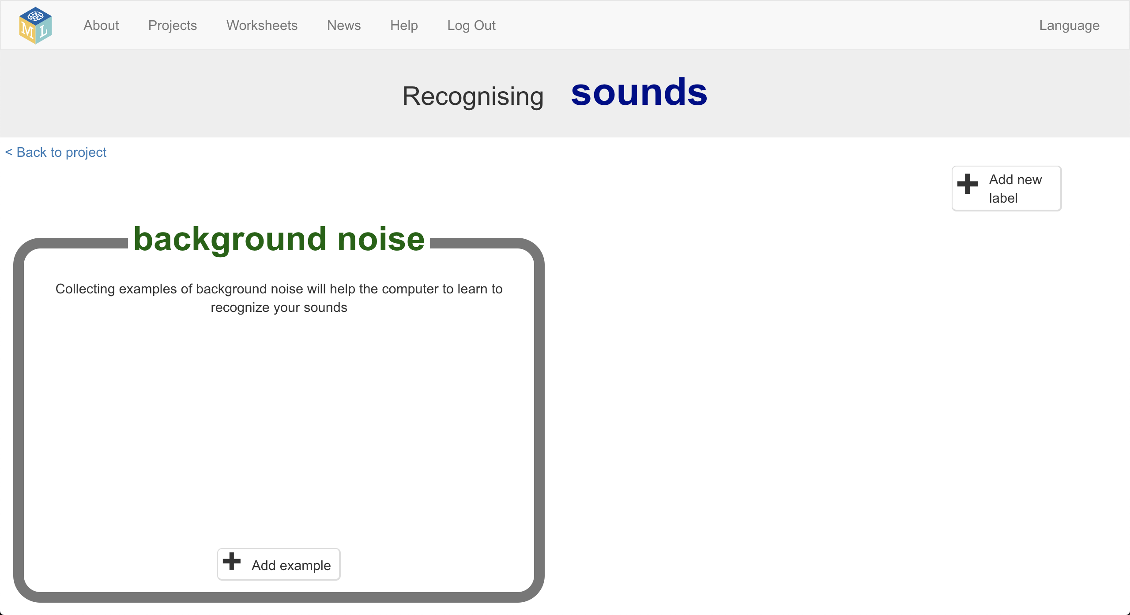
9. Click the **microphone** to record 2 seconds of background noise  
   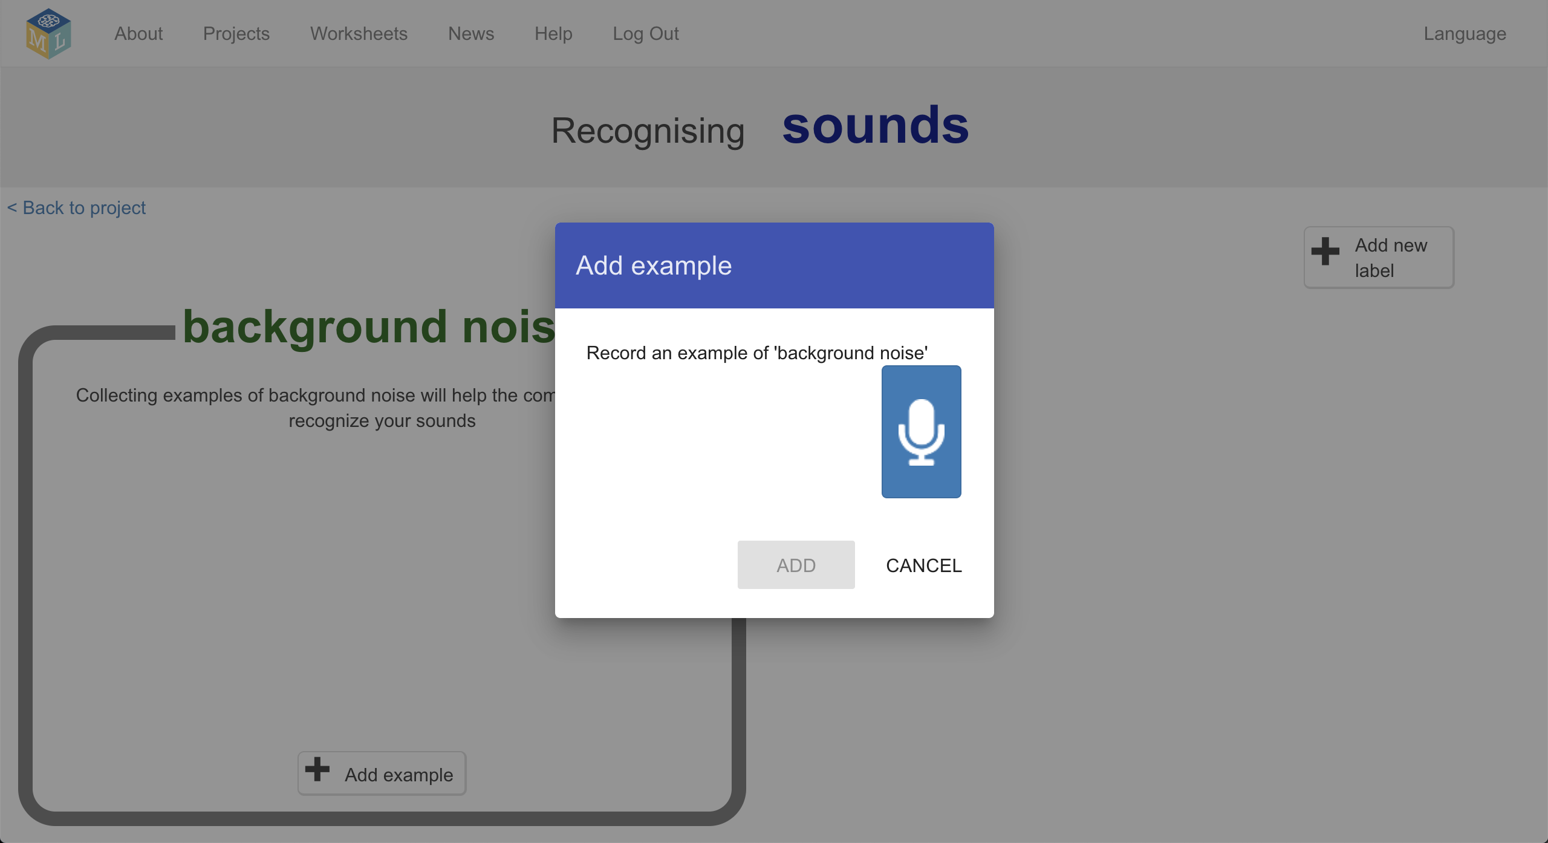
10. Click the **Add** button to save your recording   
    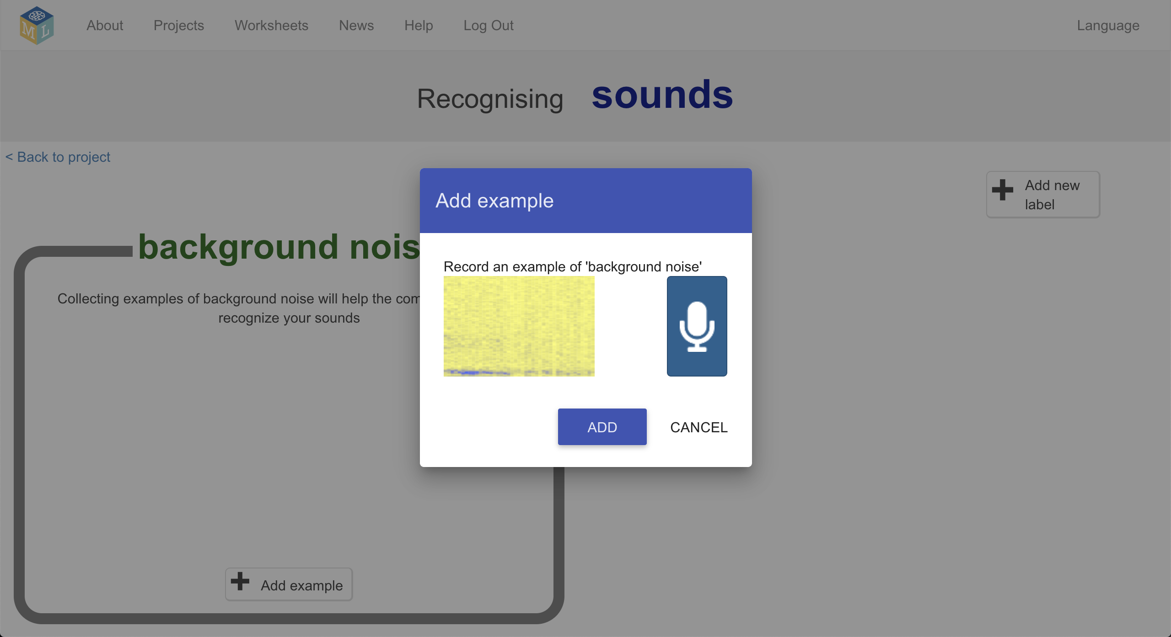
11. Repeat that until you have **at least 8** examples of background noise  
    
12. Think of some weird terms, abbreviations or acronyms that are used at your school, that people often don’t understand.   
    For my project, I’ll use these four:   
    “DSL” (*designated safeguarding lead*) “SEN” (*special educational needs*) “NQT” (*newly qualified teacher*) “EAL” (*English as an additional language*)
13. Use the **Add new label** button in the top right to create a training bucket for each of your terms  
    
14. Use the **Add example** button in each training bucket to record **eight** examples of you saying each of your jargon terms  
    *You can add more than eight if you would like, but add at least eight.*  
    
15. Click the “**Back to project**” link in the top left
16. Click the **Learn & Test** button  
    
17. Click “**Train new machine learning model**”  
    
18. Once the training is finished, click the **Start listening** button to test your machine learning model  
    *Start talking. Talk in complete sentences. Every now and then, use one of your jargon terms. Your machine learning model should recognize that you said it, and display it.*  
    
19. If you’re not happy with how the model is working, go back to the **Train** page and add more training examples.  
      
    *If your machine learning model thinks you said one term, when you actually said another one, go back and add examples of both of them so that it can learn to tell the difference between them.  
      
    If your machine learning model thinks that you said one of your jargon terms when you hadn’t said any of them, go back and add more “background noise” examples. It can help to add examples of you talking (without mentioning any of your jargon terms) to the background noise bucket, so it learns to ignore you when you’re not saying one of the special words.*
20. When you’re happy with your machine learning model, click **Make**  
    
21. Click on the **Scratch 3** button
22. Click the **Open in Scratch 3** button
23. Delete the cat sprite  
    *Click on the cross button in the sprite icon to remove it.*  
    
24. Click on the **Stage** then the **Backdrops** tab  
    
25. Create a new Backdrop using the **Paint** button  
    
26. Create a backdrop that explains the first of your jargon terms  
    *You can design your project to explain the jargon however you would like.  
    Give the costume a name that matches the jargon term, by typing in the name in the box shown by the arrow below.*  
    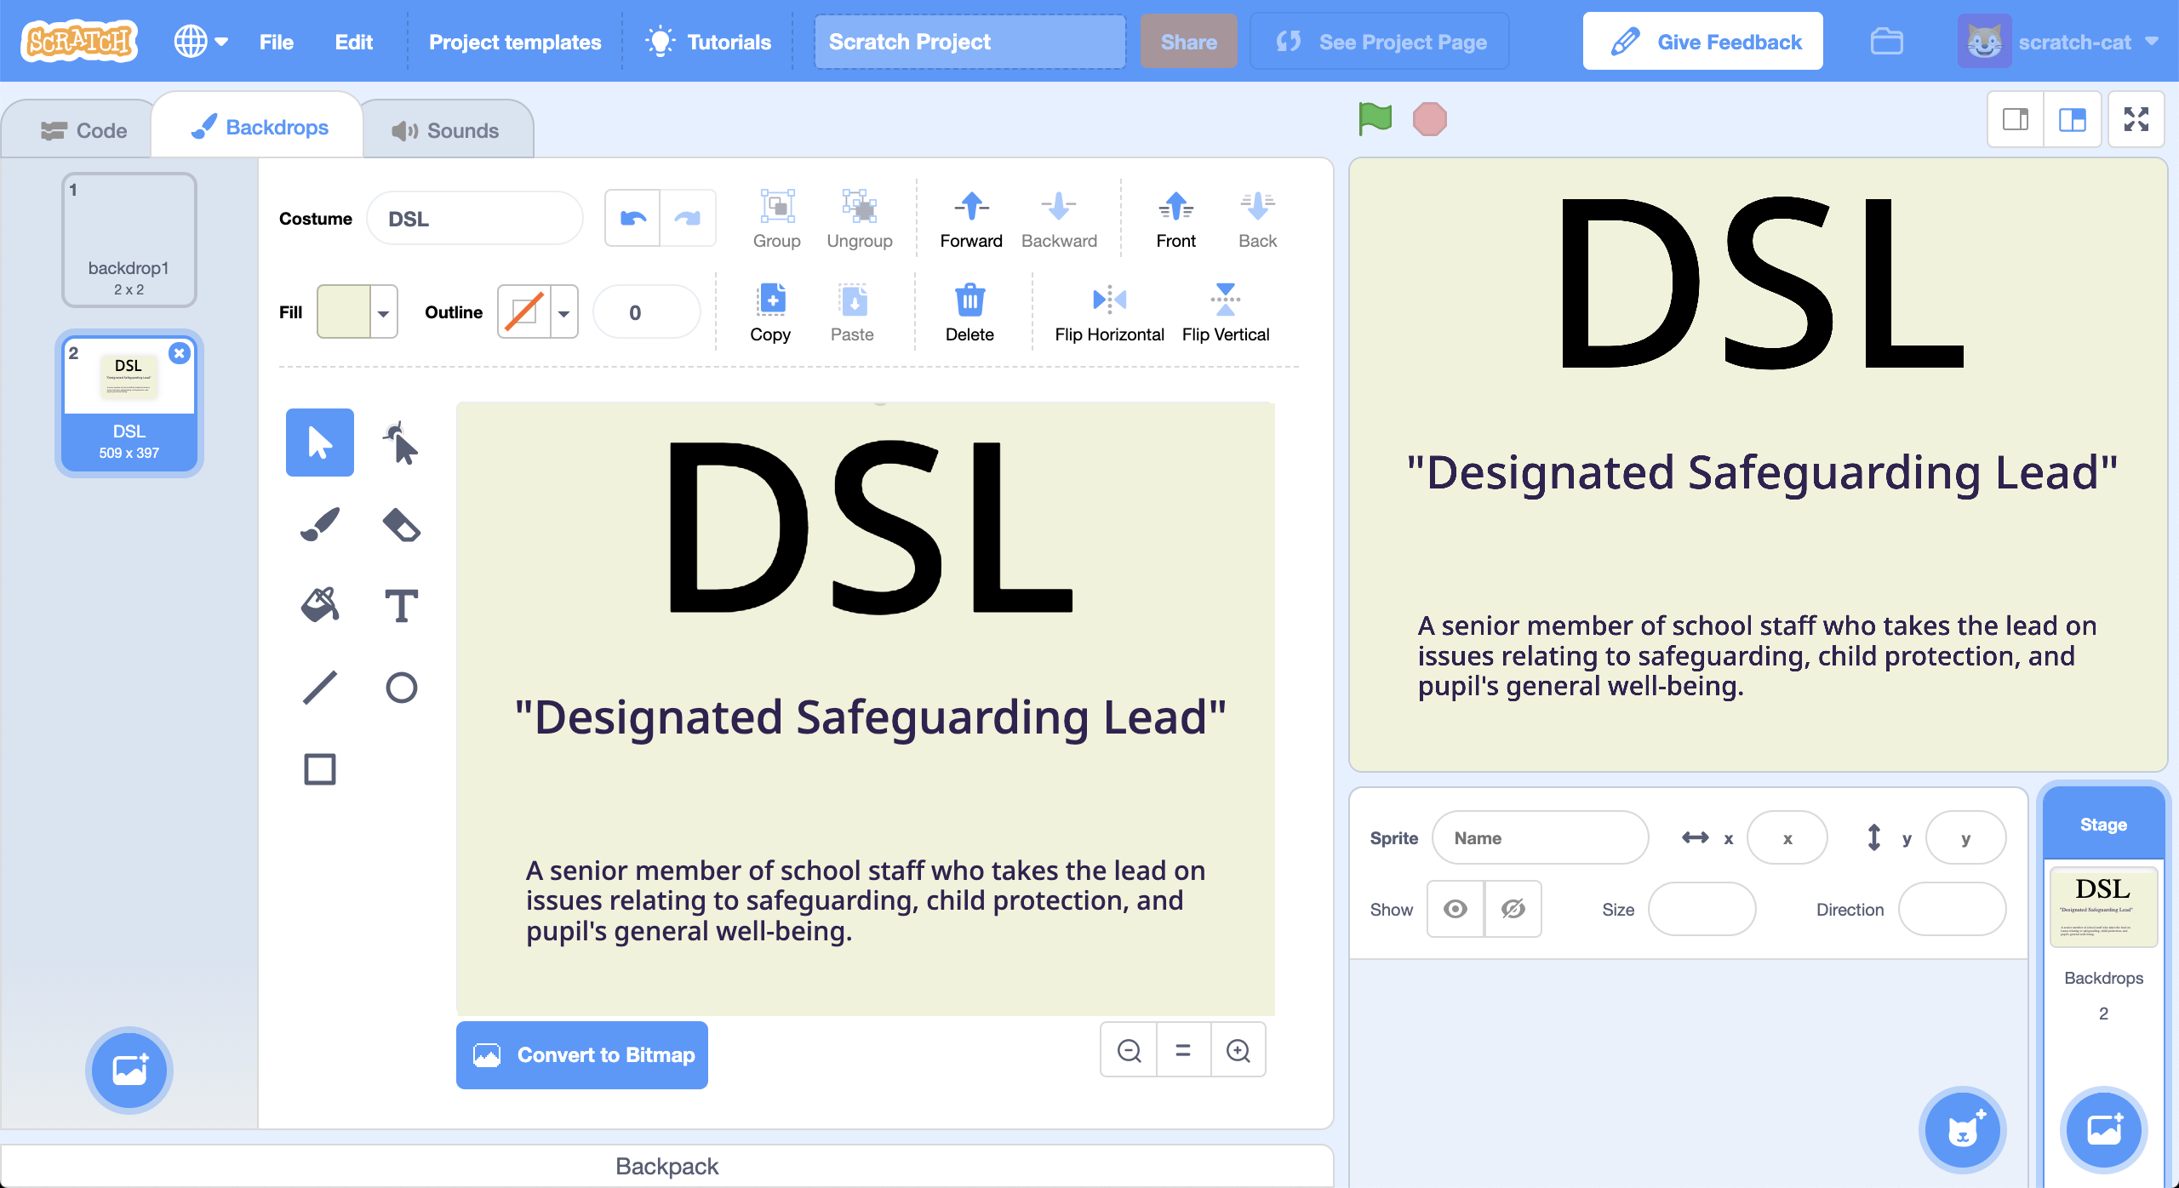
27. Use the **Paint** button again to create a costume for each of your jargon terms.   
    *Make sure you name them all to match, like you did your first one.*  
    
28. Create the following script  
    
29. It’s time to test. Click the **Green Flag**.  
    *Once your machine learning model is ready, start talking.   
    Occasionally mention one of your jargon terms. Your project should flash up an explanation of the term for a couple of seconds.*

**What have you done?**

You’ve trained a machine learning model to use for speech recognition. You used that to build a project in Scratch that listens for some special terms and react to them.

The ability to listen in the background and react to certain keywords is a common use of machine learning. Devices like Amazon’s Alexa and Apple’s Siri use this to be able to recognise when you say their name.

**Ideas and Extensions**

Now that you’ve finished, why not give one of these ideas a try?

Or come up with one of your own?

**Add new commands**

Try adding more training buckets.